**Consultation on options to improve the management of extreme threat prisoners: Discussion document 2025**

# **18 February – 31 March 2025**

# ***Summary and optional submission form***

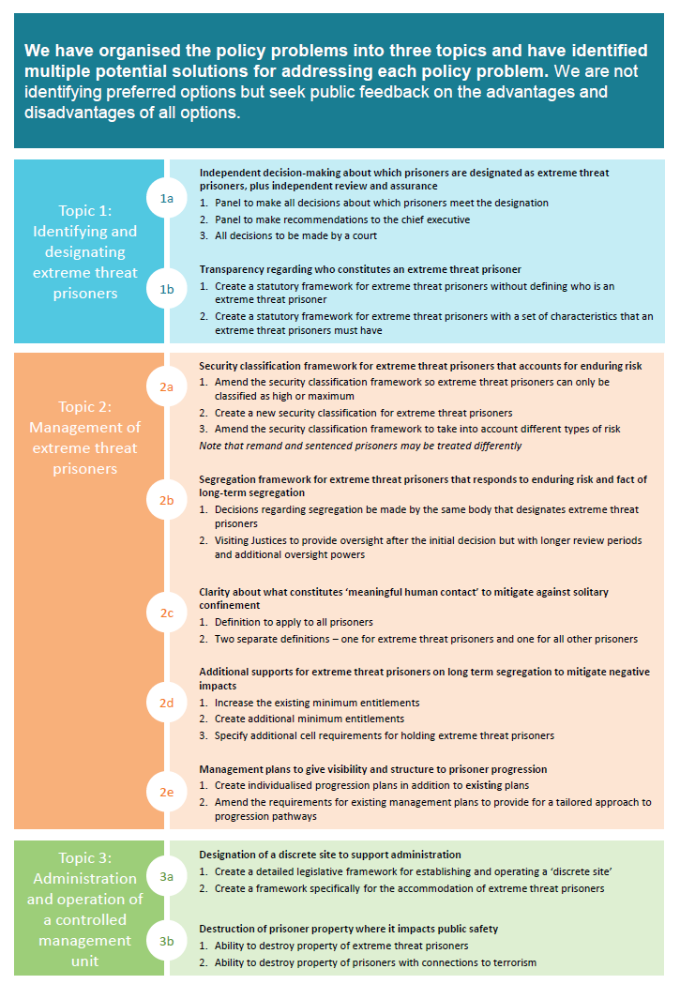

**How to make a submission**

This is an opportunity to share your views, evidence, and data, on how we could improve the management of extreme threat prisoners, to inform final advice to the Minister of Corrections.

You can make a submission by emailing us your views in the body of an email or in an attached Word document or by using this optional submission form [LegislationAmendments@corrections.govt.nz](mailto:LegislationAmendments@corrections.govt.nz). If you wish to discuss your views with us, please email us to let us know. If using this submission form you will find questions in each section to respond to.

**You do not need to respond to all of the questions if you do not wish to**. The submission period closes on 31 March 2025.

## **Your submission is public information**

After public consultation, the contents of submissions (including names of submitters) may be published on the Corrections website and released to the public if requested under the Official Information Act 1982. Unless you clearly specify otherwise in your submission, Corrections will consider that you have consented to website posting of both your submission and your name.

If you think there are grounds to withhold specific information in your submission from publication, please tick the relevant boxes on the next page and describe which parts you consider should be withheld, together with the reasons for withholding the information. Reasons that information can be withheld are set out in sections 6 and 9 of the Official Information Act and may include that the submission discloses personal information. We will take into account any requests to withhold information in submissions when responding to requests under the Official Information Act.

**Submitter information**

Please fill out the **submitter information** below. If you are representing an organisation, please ensure you have the authority to represent its views.

|  |
| --- |
| **Name:** |

|  |  |  |
| --- | --- | --- |
| **Email address:** |  | **Phone number (optional):** |

|  |
| --- |
| **If you are making this submission on behalf of a business or organisation please tell us the title of the company/organisation:** |

Would you like to be kept informed of the outcome of Corrections’ public consultation? Yes/No

**Release of information**: Please indicate if you do not wish your name and contact details to be included in any information that the Department of Corrections may publish. Yes/No

Please indicate if there is other information within your submission that you want to be kept confidential. If you have ticked this box, please state your reasons and grounds under the Official Information Act 1982 below, for consideration by the Department of Corrections. Yes/No

|  |
| --- |
|  |

# Fork In Road with solid fill**Topic 1a: Independent decision-making about which prisoners are designated as extreme threat prisoners, plus independent review and assurance**

**Introduce robust processes for the designation of extreme threat prisoners to provide transparency to prisoners and the public that decisions are impartial and can be reviewed.**

**What problems are we are trying to address?**

Currently, prisoners in the Prisoners of Extreme Risk Unit (the PERU) at Auckland Prison are being managed under a higher level of custodial management as they are considered to be the most challenging individuals to manage. The Office of the Inspectorate and the Chief Ombudsman have criticised the current process for placing prisoners in the PERU as they consider it lacks independence as the decision sits with one person who is closely aligned with the unit.

There is an opportunity to ensure there is robust, independent decision-making in place to designate extreme threat prisoners. Decision-making should take into account the risks prisoners pose, their rights, inherent dignity, and rehabilitative needs. Our goal is to ensure that extreme threat prisoners are being managed appropriately and in proportion to the level of risk that they pose to safety and security. Impacted prisoners should be able to engage in the process and seek reviews of that process.

**See pages 12 to 14 of the discussion document for more detail and our analysis of the options.**

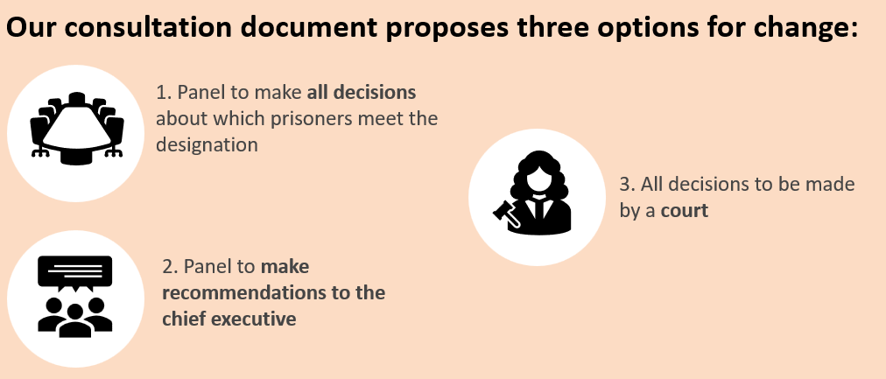

**Questions we seek your feedback on for topic 1a: Independent decision-making about which prisoners are designated as extreme threat prisoners, plus independent review and assurance**

**You may wish to consider the following criteria as you give us your feedback on the options:**

|  |  |
| --- | --- |
| * Promotes better prisoner outcomes | * Practical to implement and responsive |
| * Transparency and accountability | * Complies with human rights obligations |
| * Contributes to safety | * Contributes to better outcomes for Māori |

*More information about how to use these criteria is on page 4 and 5 of the discussion document.*

**Question 1: Do you support a panel process (option one or two), or a court process (option three) for decision making on the categorisation of extreme threat prisoners, and why?**

|  |
| --- |
|  |

**Question 2: How frequently do you think a prisoner’s designation as an extreme threat prisoner should be reviewed?**

|  |
| --- |
|  |

**Question 3:** **If option one or two is the recommended option, do you have views on what skills and experiences should be represented on the panels and what information they should take into account?**

|  |
| --- |
|  |

**Question 4: If option one or two is the recommended option, what are your views on if the panel should have a wider role in the ongoing management of prisoners?**

|  |
| --- |
|  |

**Question 5:** **Are there any other options that need to be considered?**

|  |
| --- |
|  |

**Question 6: Do you agree with our initial analysis of these options? If not, where do you have different views?**

|  |
| --- |
|  |

**Question 7: What information should a specified body be required to consider as part of the designation process?**

|  |
| --- |
|  |

# **Topic 1b: Transparency regarding who constitutes an extreme threat prisoner**

**Introduce transparency about who and what characterises an extreme threat prisoner**



**What problems are we are trying to address?**

There is no transparency about the definition of an extreme threat prisoner. At present, for extreme threat prisoners (currently referred to as prisoners of extreme risk), Corrections currently assesses the following criteria:

* risk of harm to others (including to the community, prison staff or other people in prison)
* risk of harm from others (may include those who are at imminent risk of serious harm from others)
* ability to influence others to contribute to the risk of harm to others or significant risk to the security, safety or stability of prison operations.

It is important to provide clarity to the prisoners and the general public about the criteria for someone to be managed with a higher level of custodial management.

**See pages 14 to 16 of the discussion document for more detail and our analysis of the options.**

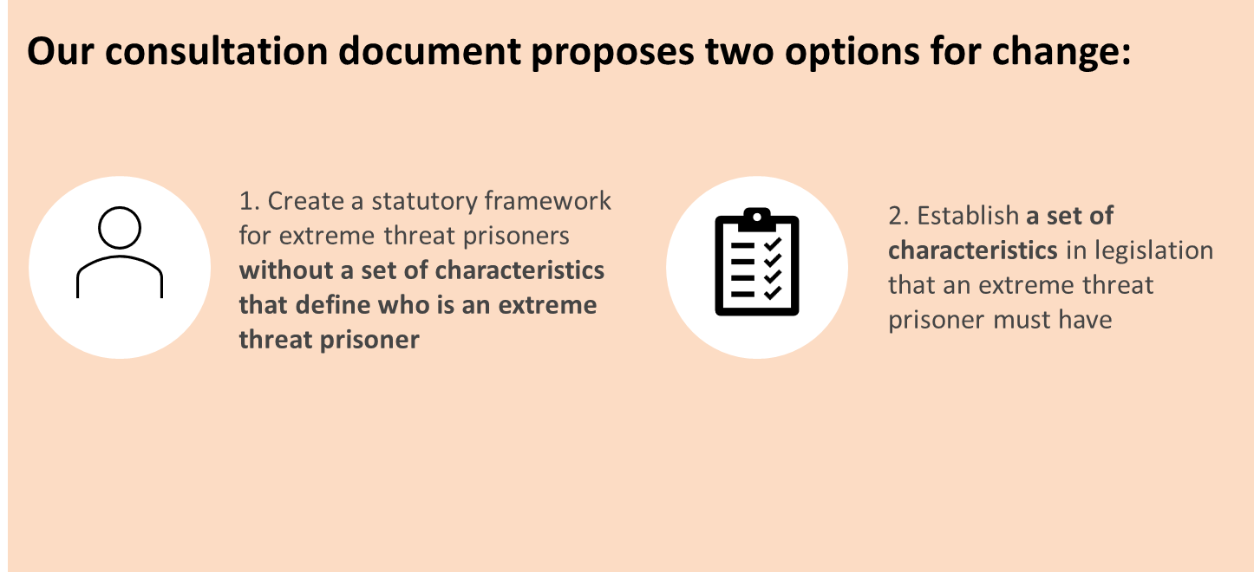

**Questions we seek your feedback on for topic 1b: Transparency regarding who constitutes an extreme threat prisoner**

**You may wish to consider the following criteria as you give us your feedback on the options:**

|  |  |
| --- | --- |
| * Promotes better prisoner outcomes | * Practical to implement and responsive |
| * Transparency and accountability | * Complies with human rights standards |
| * Contributes to safety | * Contributes to better outcomes for Māori |

*More information about how to use these criteria is on page 4 and 5 of the discussion document.*

**Question 1: Do you think it is important to provide transparency about which prisoners will be managed with a higher level of custodial management?**

|  |
| --- |
|  |

**Question 2: What is your preferred option, and why? Do you agree that it should cover all prisoners: accused, convicted, and sentenced?**

|  |
| --- |
|  |

**Question 3:** **Are there other characteristics prisoners may have that mean they should be managed with a higher level of custodial management?**

|  |
| --- |
|  |

**Question 4:** **Do you think there should be a minimum age for extreme threat prisoners? Or should prisoners of all ages be eligible for designation?**

|  |
| --- |
|  |

**Question 5: Are there any other options that need to be considered?**

|  |
| --- |
|  |

**Question 6:** **Do you agree with our initial analysis of these options? If not, where do you have different views?**

|  |
| --- |
|  |

# **Topic 2a: Security classification framework for extreme threat prisoners that fully accounts for the risk posed by these individuals**

**We will adapt security classifications for extreme threat prisoners to take into account the types of risk that such prisoners demonstrate so that we can keep prisons and the public safe.**



**What’s the problem we are trying to address?**

The current requirements for security classification do not recognise the level and type of risk posed by extreme threat prisoners. The environment in which these prisoners are managed means there is very little ability to engage in violence or other behaviours that would inform what their security classification should be. This means it can look like some prisoners no longer pose an extreme threat, whereas, they have actually just been managed in way that means they cannot demonstrate this risk.

There are other challenges with the current framework, including that it does not explicitly account for the types of risks that an extreme threat prisoner can pose. For example, the risk of influencing others and adherence to extremist ideologies. In addition, the Corrections Act requires prisoners to be informed of the reasons for their security classification even if that is sensitive intelligence information.

**See pages 18 to 19 of the discussion document for more detail and our analysis of the options.**

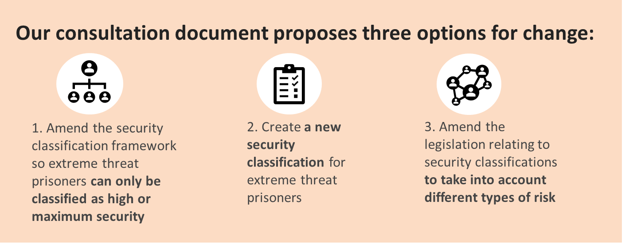

**Questions we seek your feedback on for 2a: security classification for extreme threat prisoners that accounts for enduring risk**

**You may wish to consider the following criteria as you give us your feedback on the options:**

|  |  |
| --- | --- |
| * Promotes better prisoner outcomes | * Practical to implement and responsive |
| * Transparency and accountability | * Complies with human rights obligations |
| * Contributes to safety | * Contributes to better outcomes for Māori |

*More information about how to use these criteria is on page 4 and 5 of the discussion document.*

**Question 1: What is your preferred option, and why?**

|  |
| --- |
|  |

**Question 2: Do you think there are other options we have not considered?**

|  |
| --- |
|  |

**Question 3: Do you think it is important for prisoners to receive information regarding their security classification even when that information is sensitive or restricted?**

|  |
| --- |
|  |

**Question 4: Do you agree with our initial analysis of these options? If not, where do you have different views?**

|  |
| --- |
|  |

# **Topic 2b – The current segregation framework does not adequately respond to all threats posed by extreme threat prisoners**

**Ensuring that segregation powers account for the threat that extreme threat prisoners pose to others, themselves, the prison, and the public**.



**What’s the problem we are trying to address?**

As with the security classification requirements that are set in legislation, the current segregation requirements do not acknowledge that extreme threat prisoners are likely to spend long periods of time on segregation, with a limited likelihood of changing the enduring risk they pose, and that risk is critical to them qualifying for segregation.

The characteristics of extreme threat prisoners, namely their static risk, means they are unlikely to change in a three-month period between segregation reviews. For this reason, we are exploring longer segregation periods.

**See pages 20 to 21 of the discussion document for more detail and our analysis of the options.**

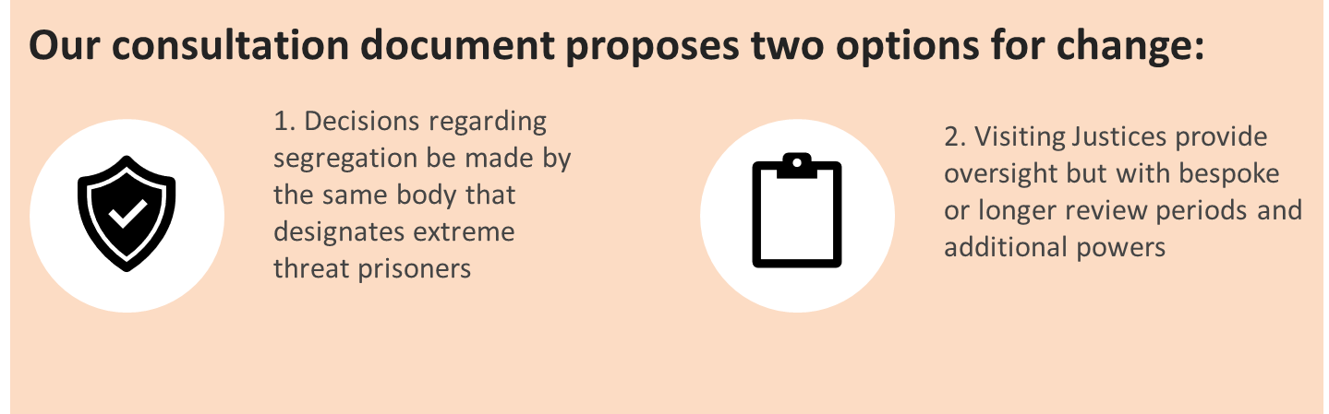

**Questions we seek your feedback on for topic 2b: Segregation framework for extreme threat prisoners that responds to enduring risk and fact of long-term segregation**

**You may wish to consider the following criteria as you give us your feedback on the options:**

|  |  |
| --- | --- |
| * Promotes better prisoner outcomes | * Practical to implement and responsive |
| * Transparency and accountability | * Complies with human rights obligations |
| * Contributes to safety | * Contributes to better outcomes for Māori |

*More information about how to use these criteria is on page 4 and 5 of the discussion document.*

**Question 1: Do you think these prisoners pose a sufficient threat to warrant longer periods of segregation with less frequent review periods?**

|  |
| --- |
|  |

**Question 2: What is an appropriate length of time for a segregation period for extreme threat prisoners?**

|  |
| --- |
|  |

**Question 3: Do you think there are other reasons segregation should be permitted, such as preventing offending outside prison and influencing others to offend?**

|  |
| --- |
|  |

**Question 4: What is your preferred option, and why?**

|  |
| --- |
|  |

**Question 5: Are there any other options that need to be considered?**

|  |
| --- |
|  |

**Question 6: Do you agree with our initial analysis of these options? If not, where do you have different views?**

|  |
| --- |
|  |

**Question 7: Should natural justice play a bigger role in decision-making for segregation?**

|  |
| --- |
|  |

# 

# **Topic 2c: Clarity about what constitutes ‘meaningful human contact’ to mitigate against solitary confinement**

**Introduce a definition of what ‘meaningful human contact’ is for either all prisoners, or extreme threat prisoners, to support Corrections staff to best to give effect to this important requirement.**



**What’s the problem we are trying to address?**

Ensuring that prisoners have meaningful human contact is a way to for Corrections staff to prevent prisoners who are segregated from experiencing solitary confinement. However, it is not defined in New Zealand law, which means there can be confusion about what it means.

There is a need for greater transparency around how Corrections understands meaningful human contact and mitigates against solitary confinement, especially for prisoners who are separated from the prison population, particularly for longer periods of time.

Below we propose two options. Both options will promote better outcomes for prisoners as the options will formally recognise meaningful human contact and provide clarity for prison staff about how to provide meaningful human contact. This means that Corrections’ prison staff know what they are expected to deliver and can better ensure they do so. Option one provides consistency across all prisoners which will mean staff have a robust understanding of what they need to do. Option two provides clarity about meaningful human contact in the wider prison network, while considering that this may look different to those who are being managed with a higher level of custodial management.

**See pages 21 to 23 of the discussion document for more detail and our analysis of the options.**

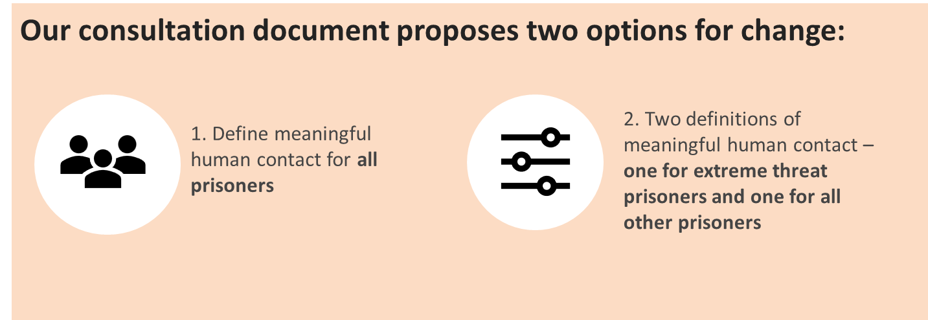

**Questions we seek your feedback on for topic 2c: Clarity about what constitutes ‘meaningful human contact’ to mitigate against solitary confinement**

**You may wish to consider the following criteria as you give us your feedback on the options:**

|  |  |
| --- | --- |
| * Promotes better prisoner outcomes | * Practical to implement and responsive |
| * Transparency and accountability | * Complies with human rights obligations |
| * Contributes to safety | * Contributes to better outcomes for Māori |

*More information about how to use these criteria is on page 4 and 5 of the discussion document.*

**Question 1: Do you agree with our initial analysis of these options? If not, where do you have different views?**

|  |
| --- |
|  |

**Question 2: Do you think extreme threat prisoners should have a different standard for what constitutes meaningful human contact?**

|  |
| --- |
|  |

**Question 3: What do you consider to be meaningful human contact?**

|  |
| --- |
|  |

**Question 4: Should a definition of meaningful human contact be in legislation or operational policy? Why?**

|  |
| --- |
|  |

# 

# **Topic 2d: Additional supports for extreme threat prisoners on long term segregation to mitigate negative impacts**

**Introduce requirements to provide additional measures and supports for extreme threat prisoners, and other prisoners, to mitigate the impact of long periods of segregation.**



**What’s the problem we are trying to address?**

Corrections currently manages all extreme threat prisoners, and others, using segregation powers to maintain the good order and safety of prisons. Research has demonstrated negative impacts when prisoners spend long periods of time isolated from other prisoners.

We are considering introducing appropriate additional measures for extreme threat prisoners, and potentially other prisoners, that mitigate against any negative impacts from long-term segregation. There is an opportunity to transparently record an obligation for Corrections to mitigate the impacts and identify the types of actions that prison staff can take to mitigate negative impacts on prisoner wellbeing where prisoners are segregated for long-periods.

The options below are not mutually exclusive and could be combined. There are also options as to whether this is provided for in legislation or operational policy. Legislative options will increase accountability of Corrections to all impacted parties and monitoring entities.

In contrast to what we are considering, some jurisdictions, including New South Wales, place limits on entitlements for prisoners they consider to be extreme threats.

We would need to identify a segregation timeframe that is appropriate to start providing additional support which could apply to prisoners other than just extreme threat prisoners. This may be relevant for all options below and could relate to segregation periods of over 15 days, over three months, or over six months.

**See pages 23 to 25 of the discussion document for more detail and our analysis of the options.**

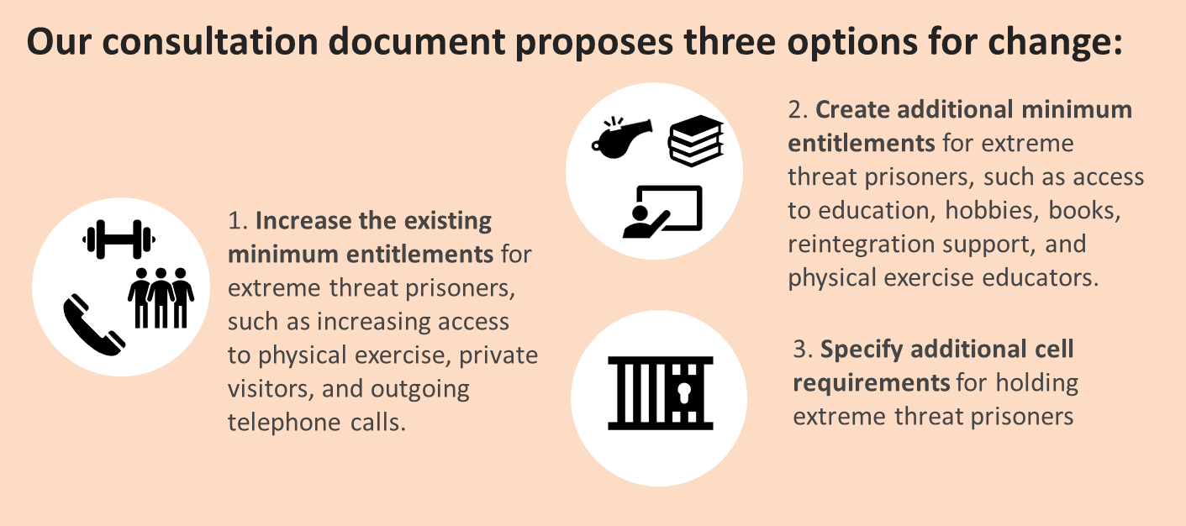

**Questions we seek your feedback on for topic 2d: Additional supports for extreme threat prisoners on long term segregation to mitigate negative impacts**

**You may wish to consider the following criteria as you give us your feedback on the options:**

|  |  |
| --- | --- |
| * Promotes better prisoner outcomes | * Practical to implement and responsive |
| * Transparency and accountability | * Complies with human rights obligations |
| * Contributes to safety | * Contributes to better outcomes for Māori |

*More information about how to use these criteria is on page 4 and 5 of the discussion document.*

**Question 1: What is your preferred option, and why?**

|  |
| --- |
|  |

**Question 2: Should changes to minimum entitlements apply to just extreme threat prisoners or all prisoners who experience long-term segregation?**

|  |
| --- |
|  |

**Question 3: What is an appropriate time before someone is considered to be on long-term segregation and additional entitlements apply? As an example, over 15 days, three months, or six months?**

|  |
| --- |
|  |

**Question 4: What additional entitlements do you think will make the most difference to the wellbeing of the prisoner?**

|  |
| --- |
|  |

**Question 5: Do you agree with our initial analysis of these options? If not, where do you have different views?**

|  |
| --- |
|  |

# **Topic 2e: Management plans to give visibility and structure to prisoner progression**

**There is an opportunity for legislative requirements to be introduced that more transparently demonstrate how extreme threat prisoners, who are managed with a higher level of custodial staffing, are given access to more individualised support.**



**What’s the problem we are trying to address?**

Most extreme threat prisoners do not meet the eligibility criteria to attend group rehabilitation programmes such as for sexual and violent offending, education, or cultural programmes. Instead, these prisoners are offered highly-individualised one-to-one sessions with a psychologist as well as other service providers or educators to meet their needs. The goal of our proposed legislative change is to provide confidence to prisoners, monitoring entities, and others that Corrections is supporting prisoners to make progress in their rehabilitation and use their time constructively.

**See pages 25 to 28 of the discussion document for more detail and our analysis of the options.**

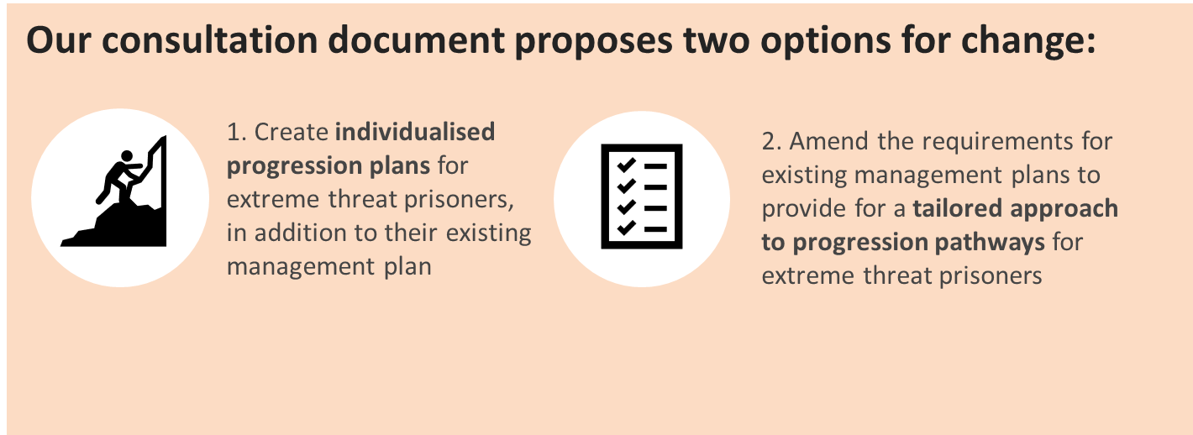

**Questions we seek your feedback on for topic 2e:** **management plans to give visibility and structure to prisoner progression**

**You may wish to consider the following criteria as you give us your feedback on the options:**

|  |  |
| --- | --- |
| * Promotes better prisoner outcomes | * Practical to implement and responsive |
| * Transparency and accountability | * Complies with human rights obligations |
| * Contributes to safety | * Contributes to better outcomes for Māori |

*More information about how to use these criteria is on page 4 and 5 of the discussion document.*

**Question 1: Do you think that a tailored approach to rehabilitation is required for extreme threat prisoners to recognise the different way in which they need to be managed?**

|  |
| --- |
|  |

**Question 2: What is your preferred option to support extreme threat prisoners’ rehabilitation outcomes and opportunities for progression? Please explain why.**

|  |
| --- |
|  |

**Question 3: Have we captured all the advantages and disadvantages of ensuring that each extreme threat prisoner has a clear and individualised progression pathway? Are we missing anything?**

|  |
| --- |
|  |

**Question 4: Are there any other Māori or other cultural perspectives that should be considered?**

|  |
| --- |
|  |

**Question 5: Are there any other impacts that we should consider?**

|  |
| --- |
|  |

**Question 6: Are there any other options to address these issues that we should consider?**

|  |
| --- |
|  |

# **Topic 3a: Introducing the supporting statutory framework for the establishment of a controlled management unit**

**Introducing the necessary legal powers for the existence of a controlled management unit and its effective administration and operation within a host prison site.**



**What’s the problem we are trying to address?**

It is not clear how a discrete site, as the PERU has been declared by the Chief Executive, interacts with the host prison, in that case Auckland Prison. There is a need for shared facilities and services such as the receiving office and gatehouse, but the units that house the prisoners are managed separately within the larger prison. While Corrections can operate special-purpose units without needing that to be authorised in law, the current state of the PERU as a discrete site lacks a supporting statutory framework. This has contributed to a lack of clarity and transparency observed by the Chief Ombudsman around the operations of the PERU.

Legislative change would give clear roles and responsibilities to a prison unit that sits within a host prison. Our goal is to provide a statutory framework for a controlled management unit within a host prison and its effective administration and operation on a daily basis where some spaces are shared and others are not.

**See pages 29 to 31 of the discussion document for more detail and our analysis of the options.**

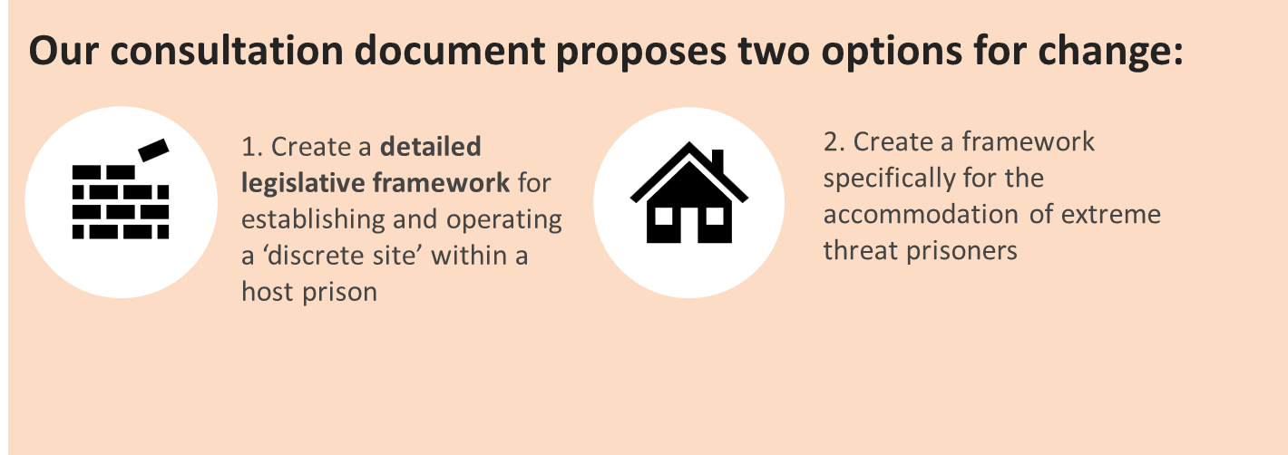

**Questions we seek your feedback on for topic 3a:** **designation of a discrete site to support administration**

**You may wish to consider the following criteria as you give us your feedback on the options:**

|  |  |
| --- | --- |
| * Promotes better prisoner outcomes | * Practical to implement and responsive |
| * Transparency and accountability | * Complies with human rights obligations |
| * Contributes to safety | * Contributes to better outcomes for Māori |

*More information about how to use these criteria is on page 4 and 5 of the discussion document.*

**Question 1: Which of these two options relating to the framework for a controlled management unit do you think would be better and why?**

|  |
| --- |
|  |

**Question 2: Do you agree with our initial analysis of these options? If not, where do you have different views?**

|  |
| --- |
|  |

**Question 3: Do you think there should be additional record-keeping requirements for a controlled management unit to acknowledge the higher level of custodial management?**

|  |
| --- |
|  |

# **Topic 3b: Destruction of prisoner property where it impacts public safety**

**We are exploring giving Corrections the power to destroy the property of prisoners when it could cause public harm, which is most likely the case for prisoners convicted of certain terrorism offences.**



**What’s the problem we are trying to address?**

Corrections has an important role in protecting the public from harm and this is increasingly important for extreme threat prisoners, in particular prisoners convicted of terrorism offences whose property, if it was to be released from prison, could cause public harm. Everyday items may become a form of memorabilia that has value to members of the public who “follow” the prisoner. Owning a book, piece of clothing, or item of other property that has been used by a terrorist can have significant meaning for some followers and could be implicated in their own radicalisation.

Both options below would require a robust operational process to be established. This would include a time period before which Corrections can destroy property, which could be a regular interval or at the time of leaving custody or death, and if at a regular interval, establishing how to decide when a prisoner no longer wants or needs that property.

**See pages 31 to 33 of the discussion document for more detail and our analysis of the options.**

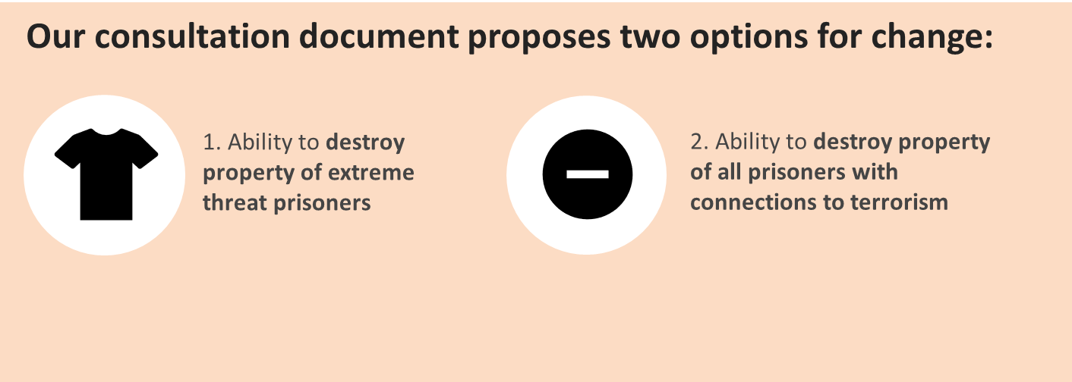

**Questions we seek your feedback on for topic 3b:** **destruction of prisoner property where it impacts public safety**

**You may wish to consider the following criteria as you give us your feedback on the options:**

|  |  |
| --- | --- |
| * Promotes better prisoner outcomes | * Practical to implement and responsive |
| * Transparency and accountability | * Complies with human rights obligations |
| * Contributes to safety | * Contributes to better outcomes for Māori |

*More information about how to use these criteria is on page 4 and 5 of the discussion document.*

**Question 1: Do you think Corrections should have additional powers to destroy the property of all extreme threat prisoners, or just the property of terrorists?**

|  |
| --- |
|  |

**Question 2: How do you think a terrorist prisoner should be defined?**

|  |
| --- |
|  |

**Question 3: What is an appropriate length of time to pass before Corrections can destroy the property?**

|  |
| --- |
|  |

**Question 4: Are there any other options that need to be considered?**

|  |
| --- |
|  |

**Question 5: Do you agree with our initial analysis of these options? If not, where do you have different views?**

|  |
| --- |
|  |

**Question 6: What principles should guide the power to destroy prisoner property?**

|  |
| --- |
|  |